1. **Demonstrate installing and setting up for wodpress/Jommla.**

Answer:

Step 1 : Run the wordpress folder on the browser eg.localhost/wordpress.

Step 2 : Select language for the wordpress.

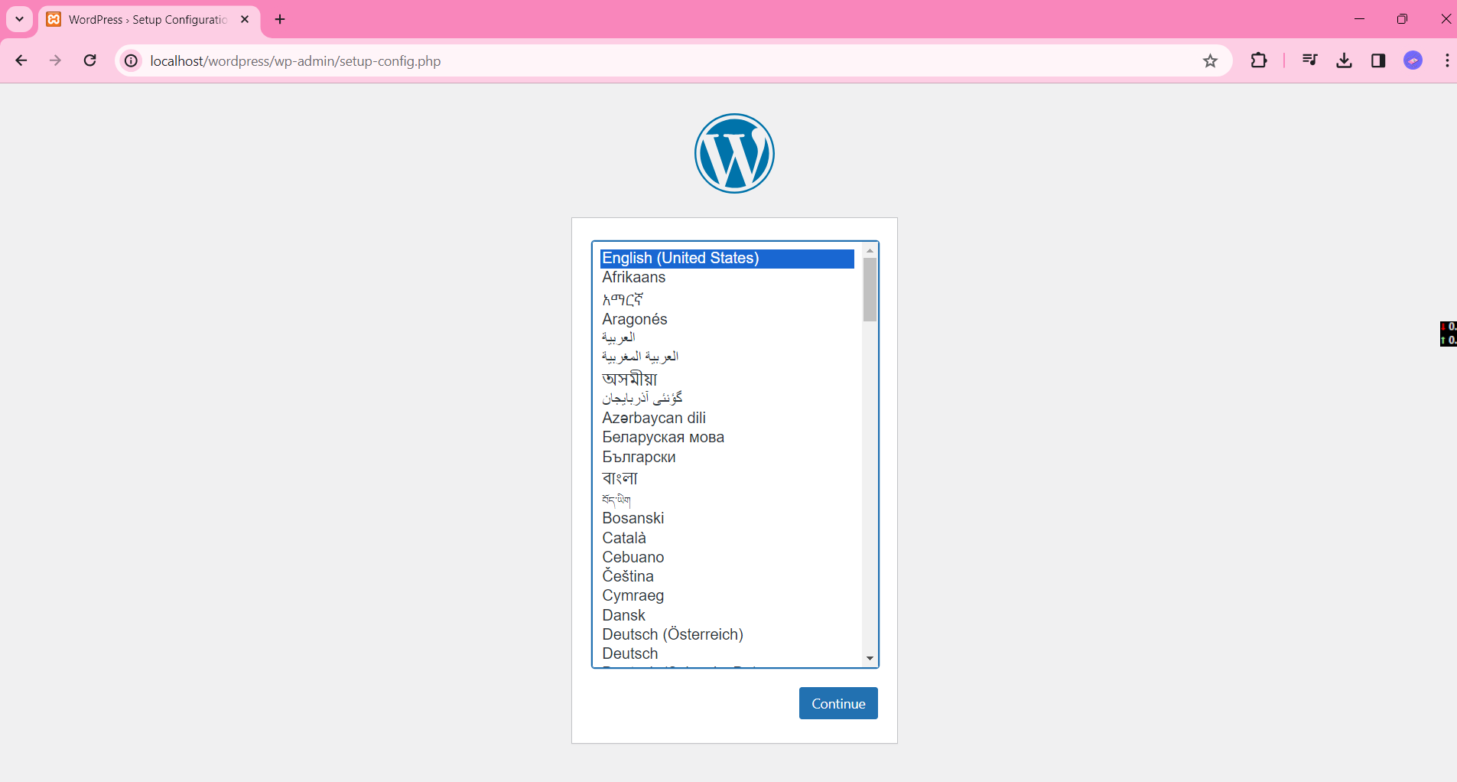

Step 3: Click on the Let’s go ! Button

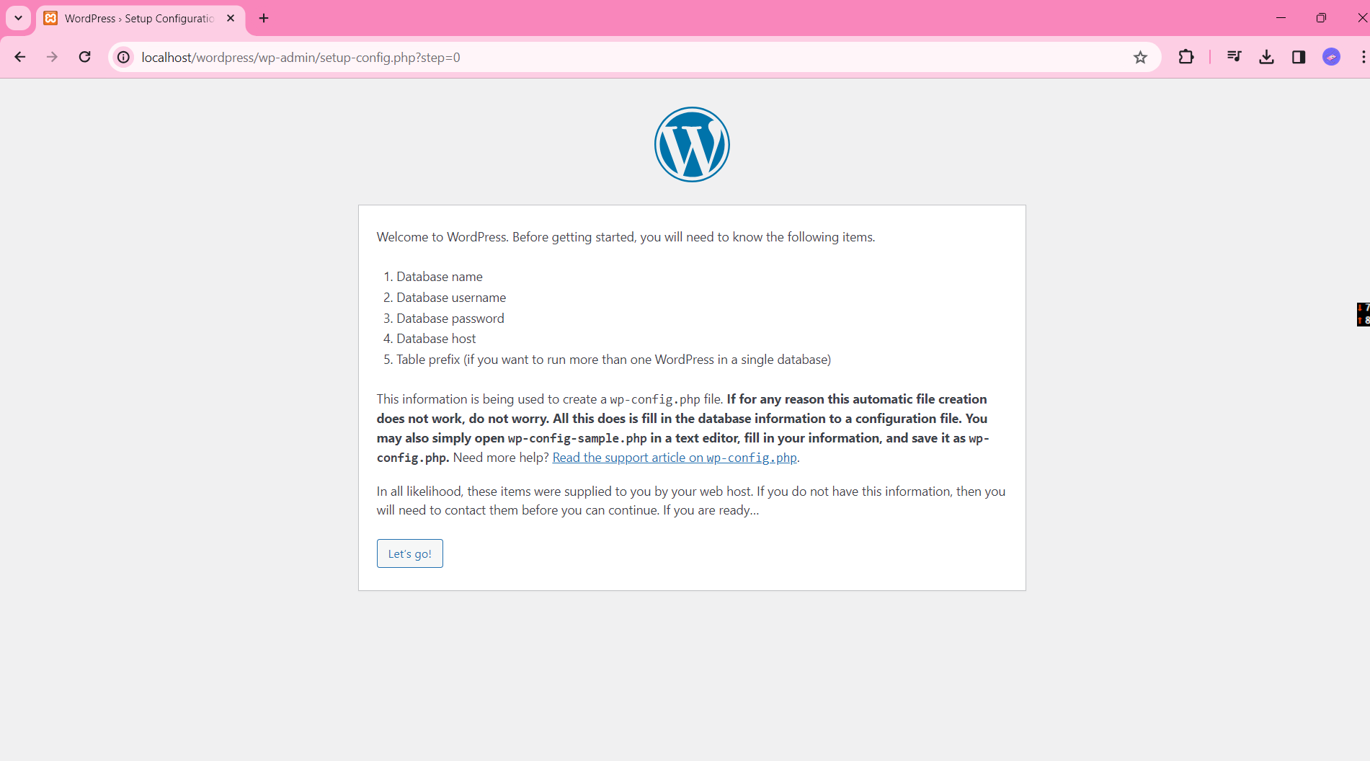

Step 4: Enter your database name, username, password of your database and click submit.

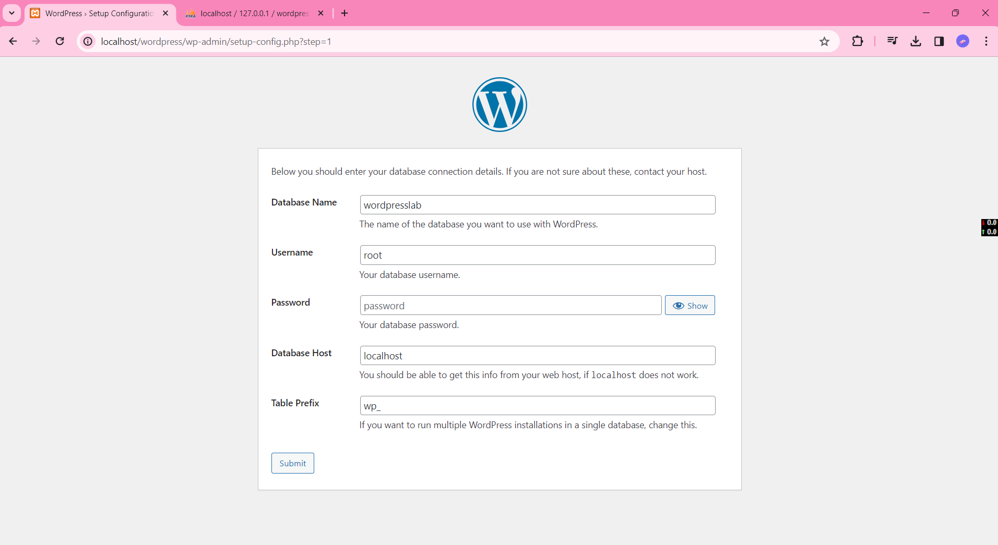

Step 5: Click the run the installation button

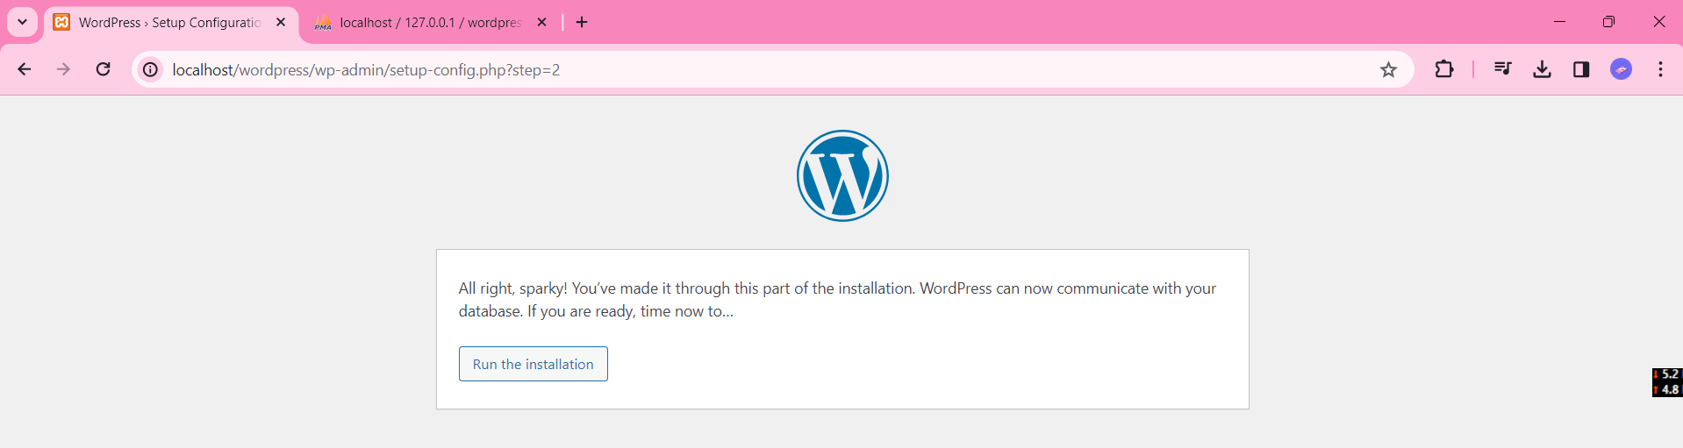

Step 6: Set Site, username and password for the site.

Step 7: Click on the log in hyperlink at the bottom left corner.

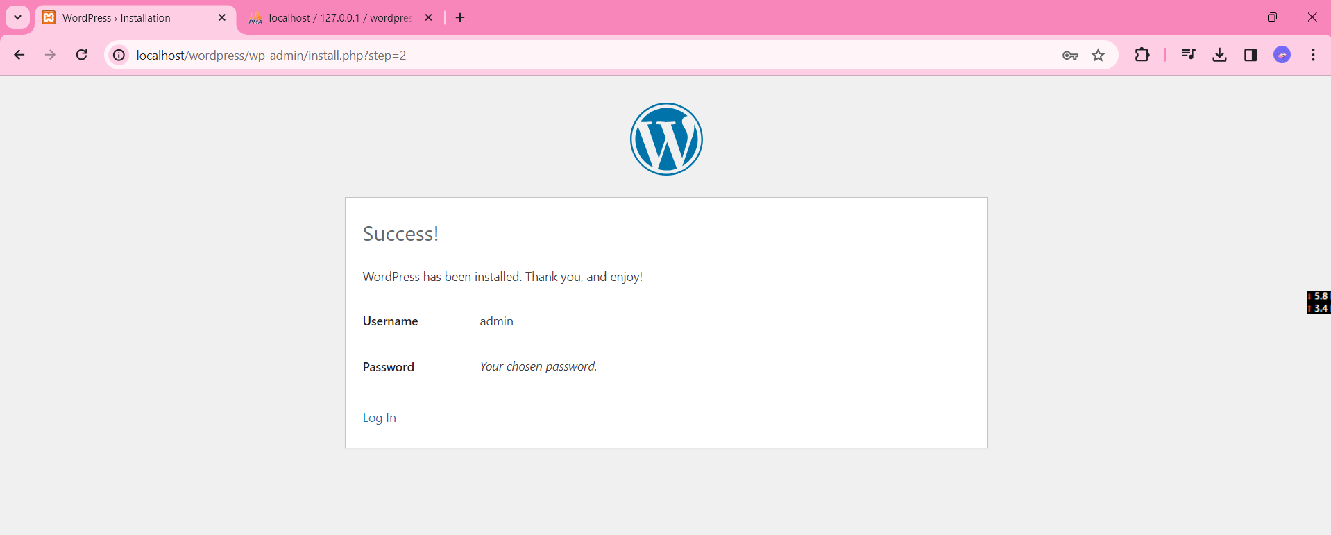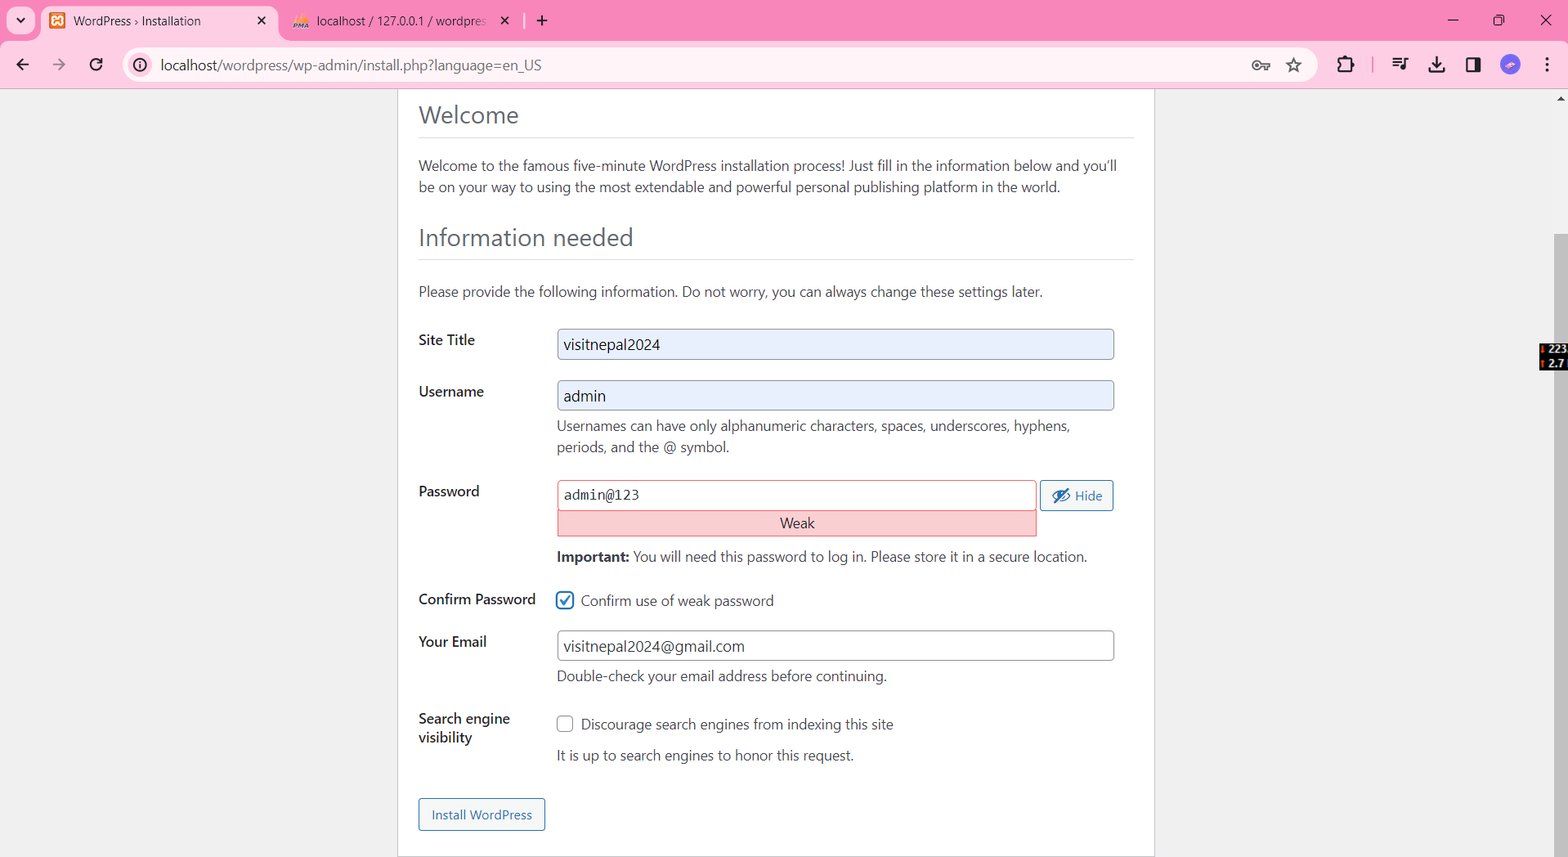

Step 8: Login with the username and password of the site.

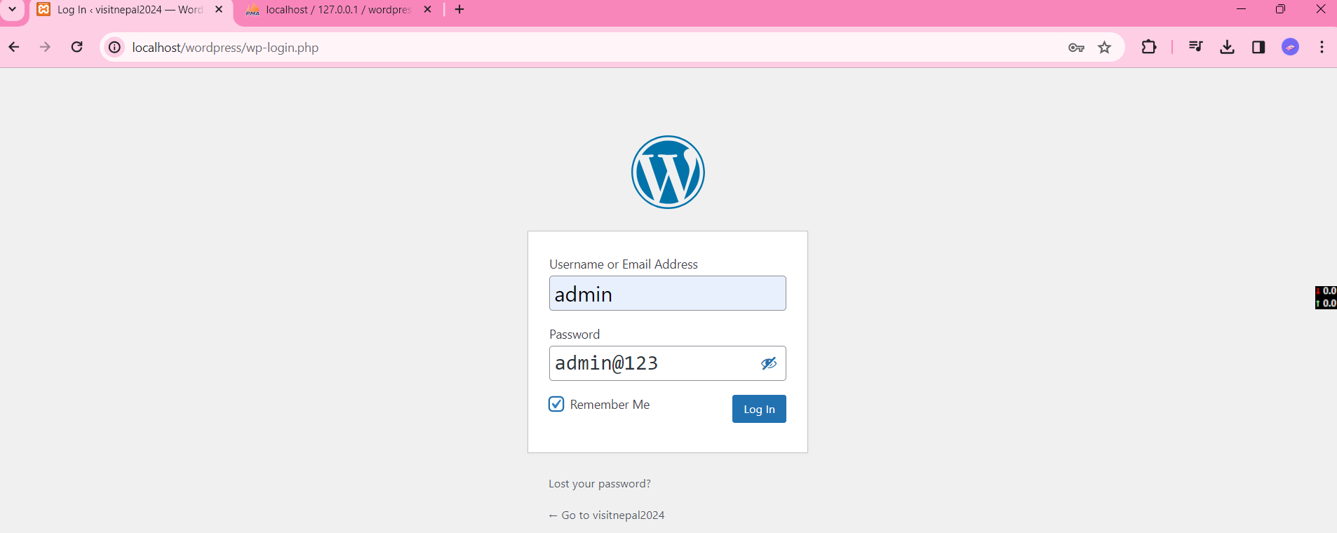

Step 9: After logging in, the site dashboard will appear.

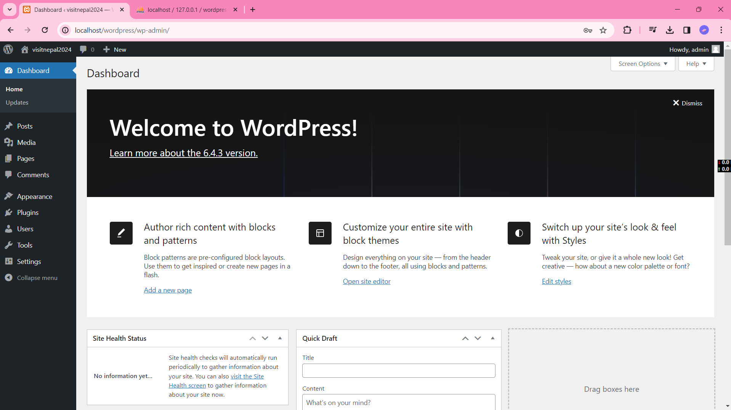

1. **Demonstrate how to add a post in wordpress/joomla page.**

Answer:

Step 1: Click on the Posts menu and click add new post menu.

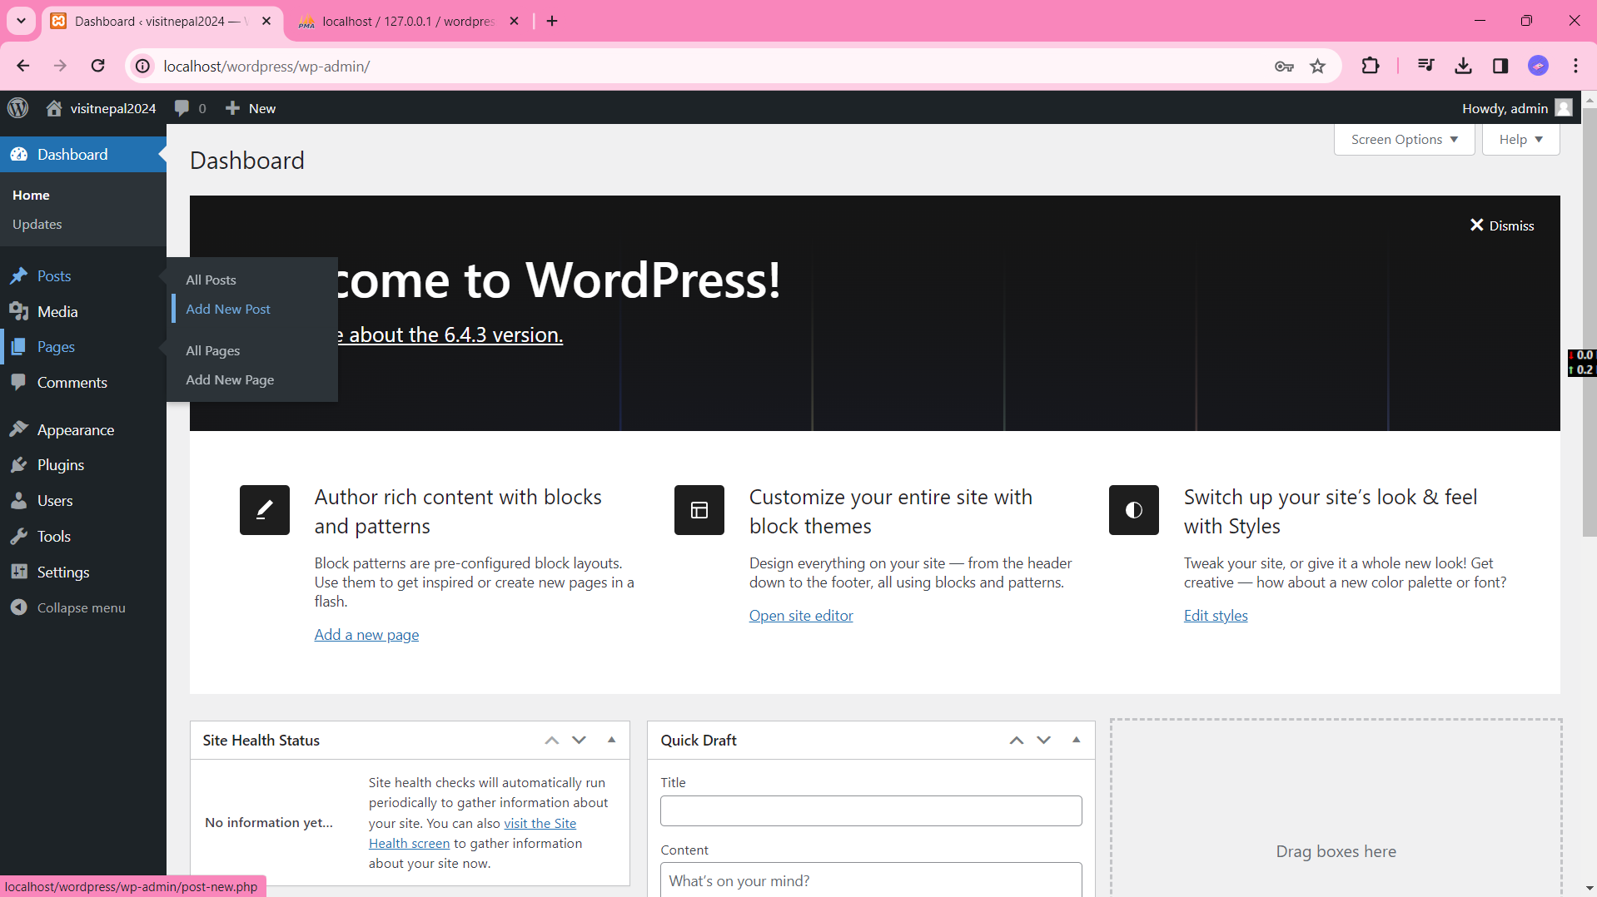

Step 2: Add the post title and description of the post.

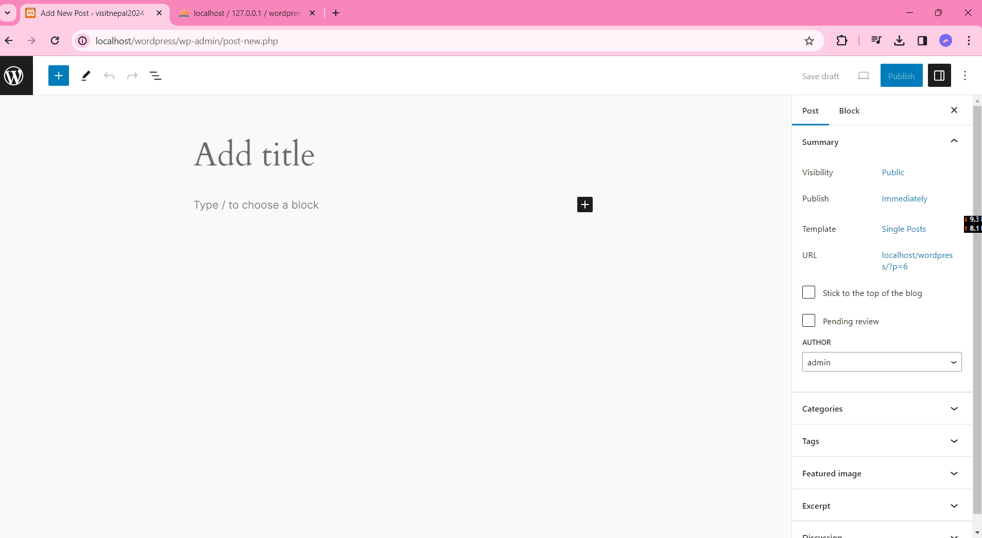

Step 3: After Writing the post click publish button on the top right corner to publish your post

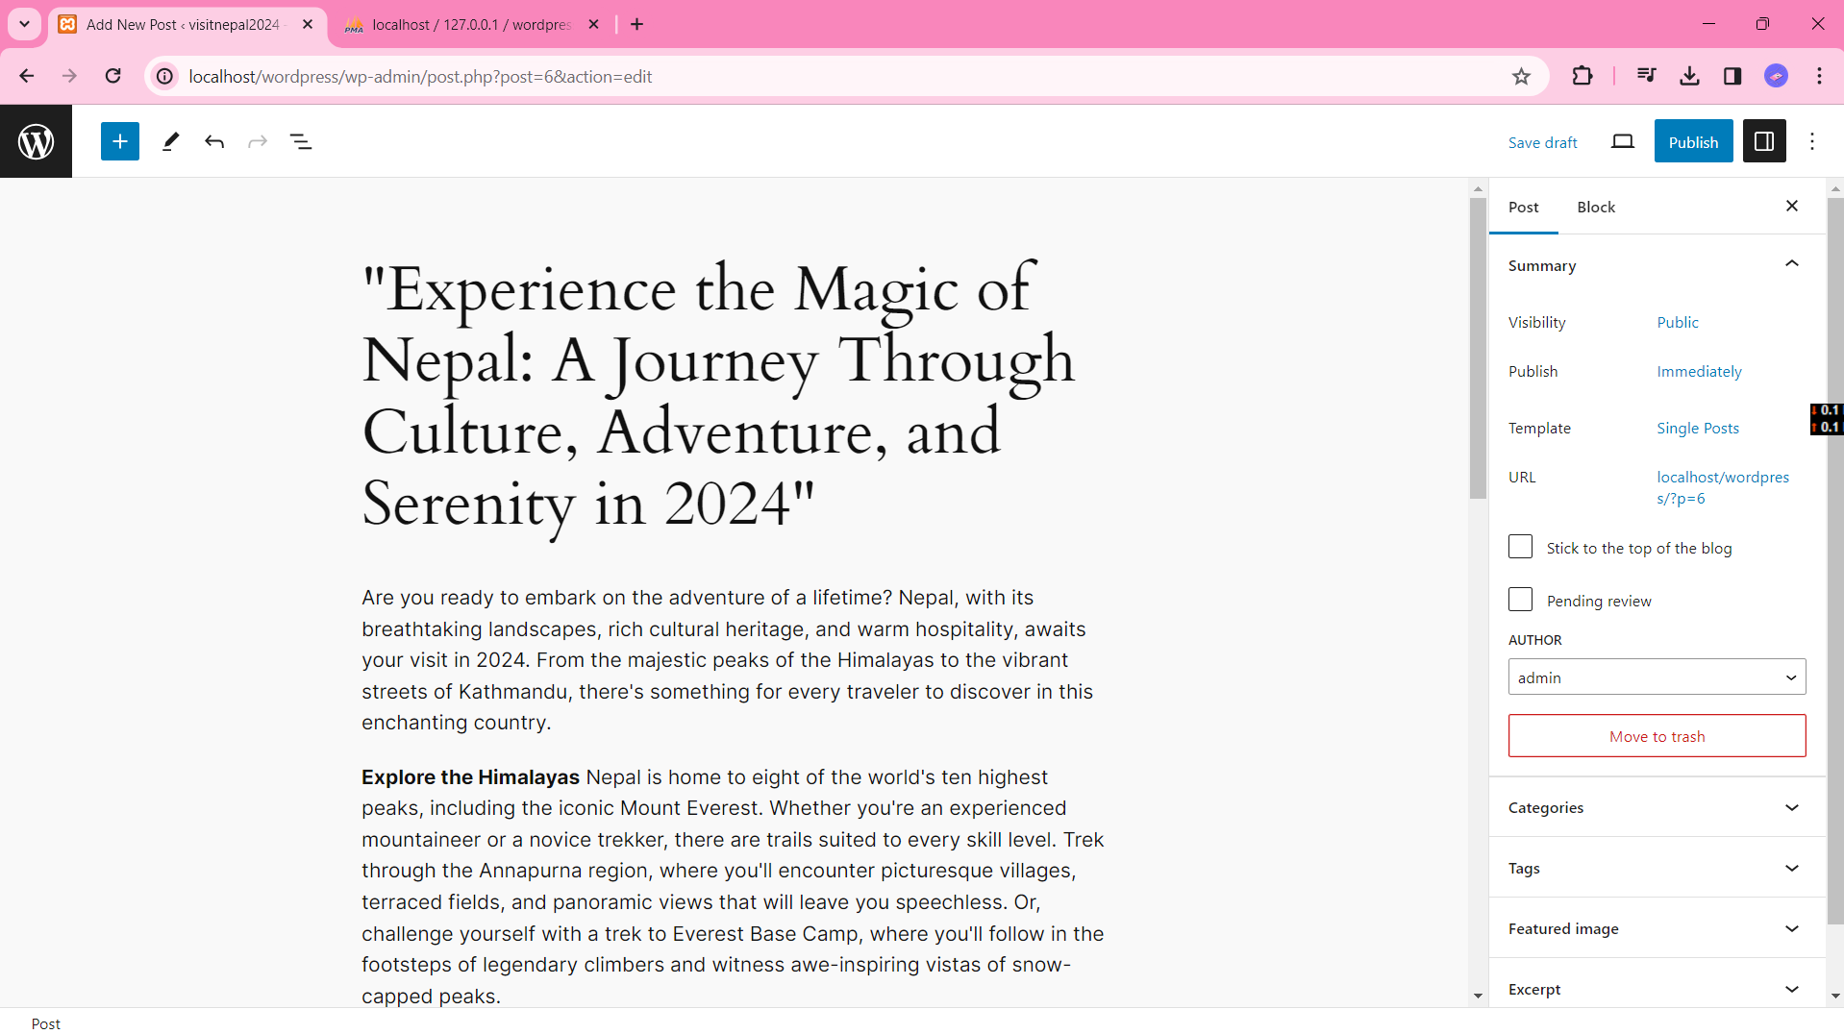

Step 4: View your post.

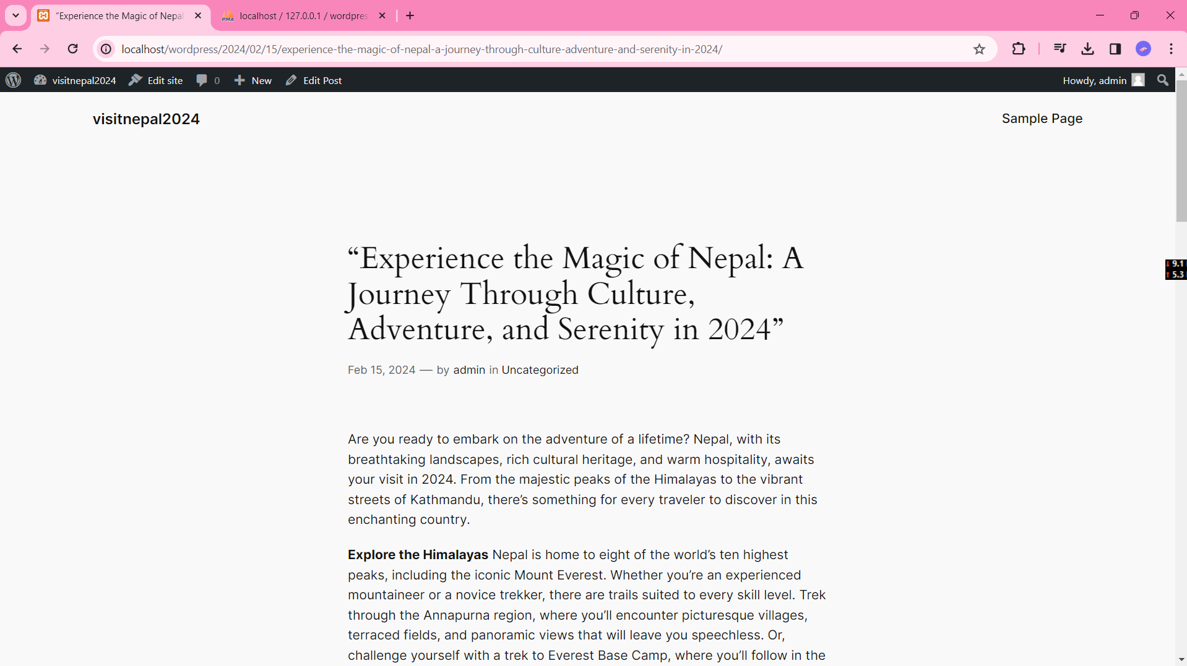

1. **Demonstrate how to add navigation menu in joomla/wordpress.**

Step 1: Click on the Appearance menu, then, click themes.

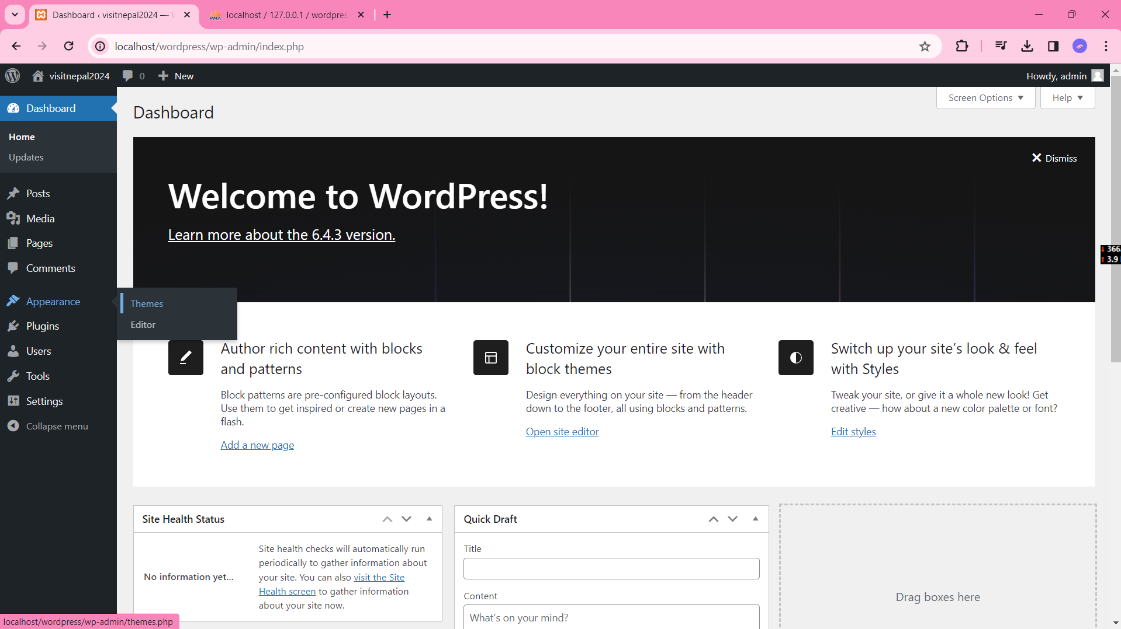

Step 2: Click on the customize button of the active theme.

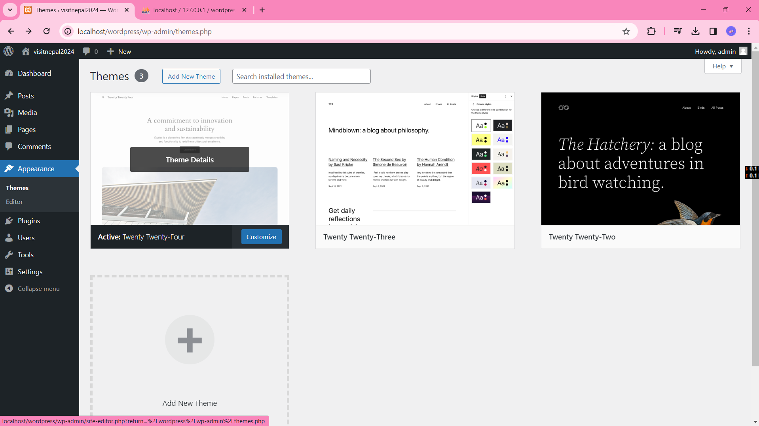

Step 3: Click on the navigation menu.

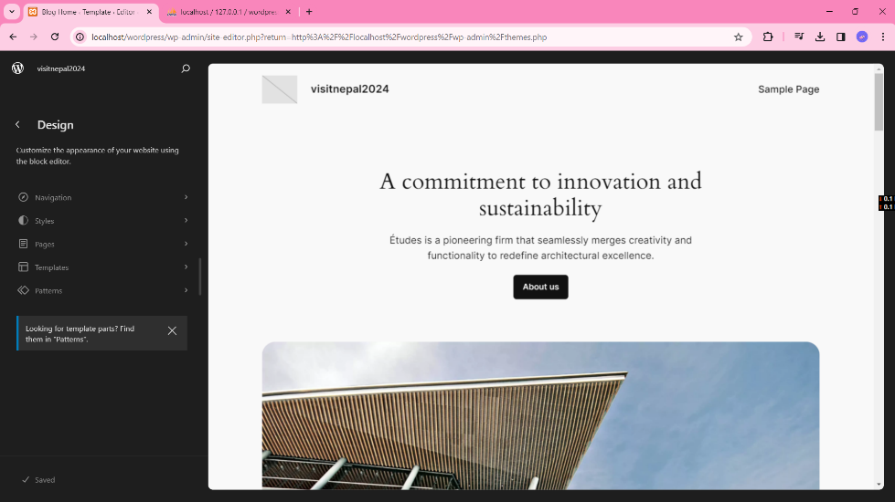

Step 4: Click on the edit icon next to three dots.

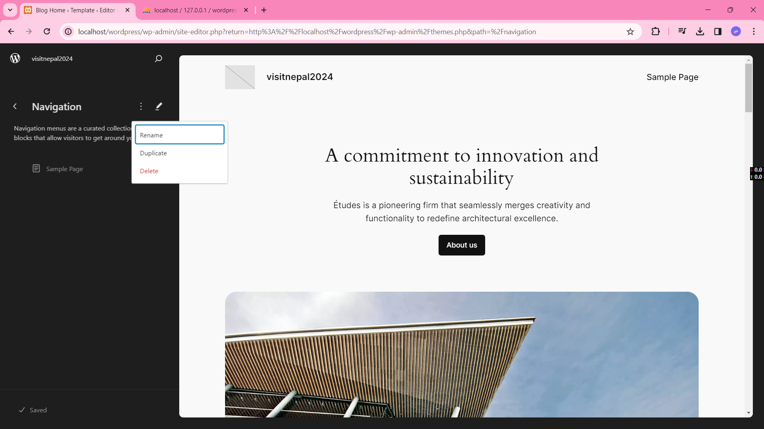

Step 5: Click on the plus icon and click on the link whose icon to be added and click save button on the top right corner.

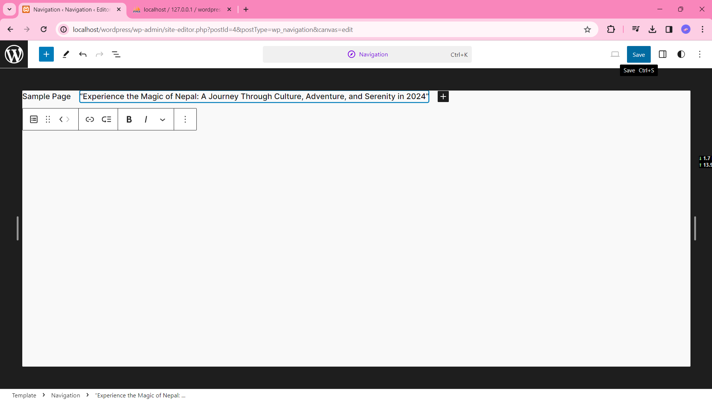

Step 6: View the site

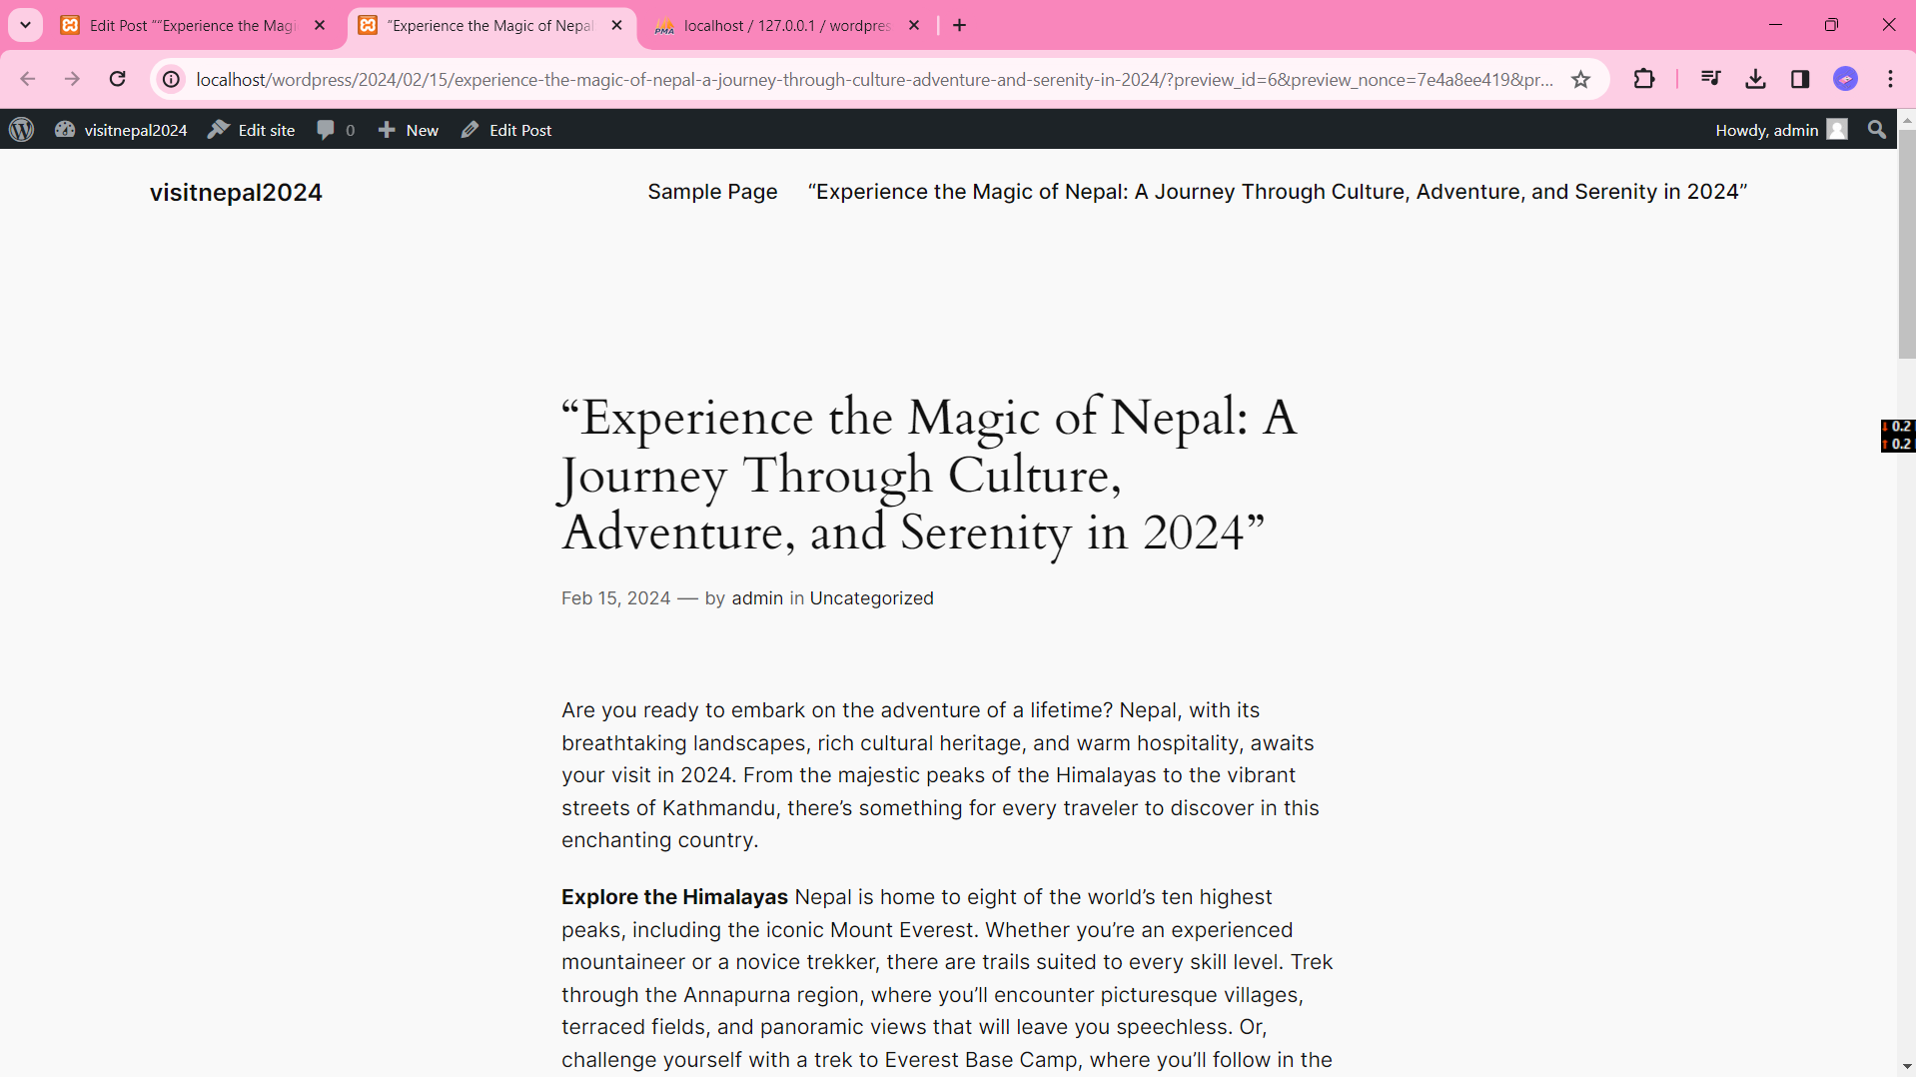

1. **How to change theme color in wordpress/Joomla?**

Step 1: Click on the Appearance menu, then click editor menu.

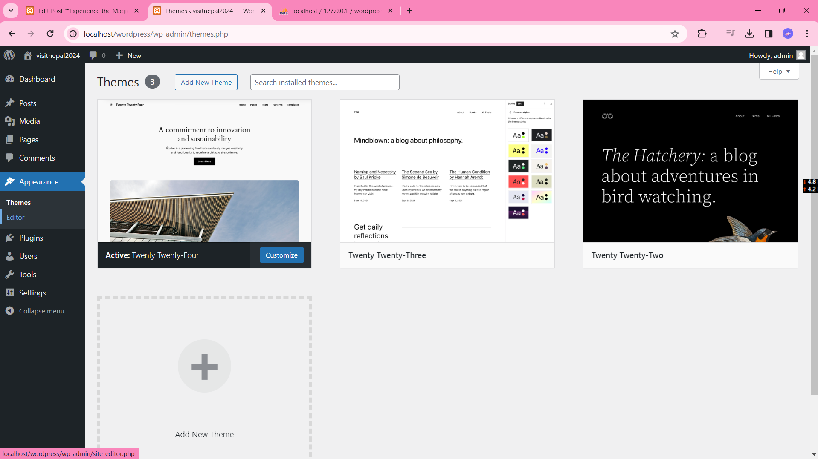

Step 2: Click styles menu.

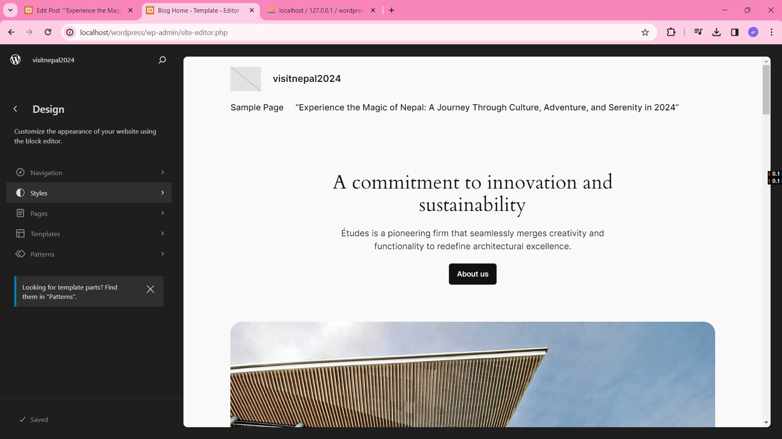

Step 3: Choose the desired color and click save.

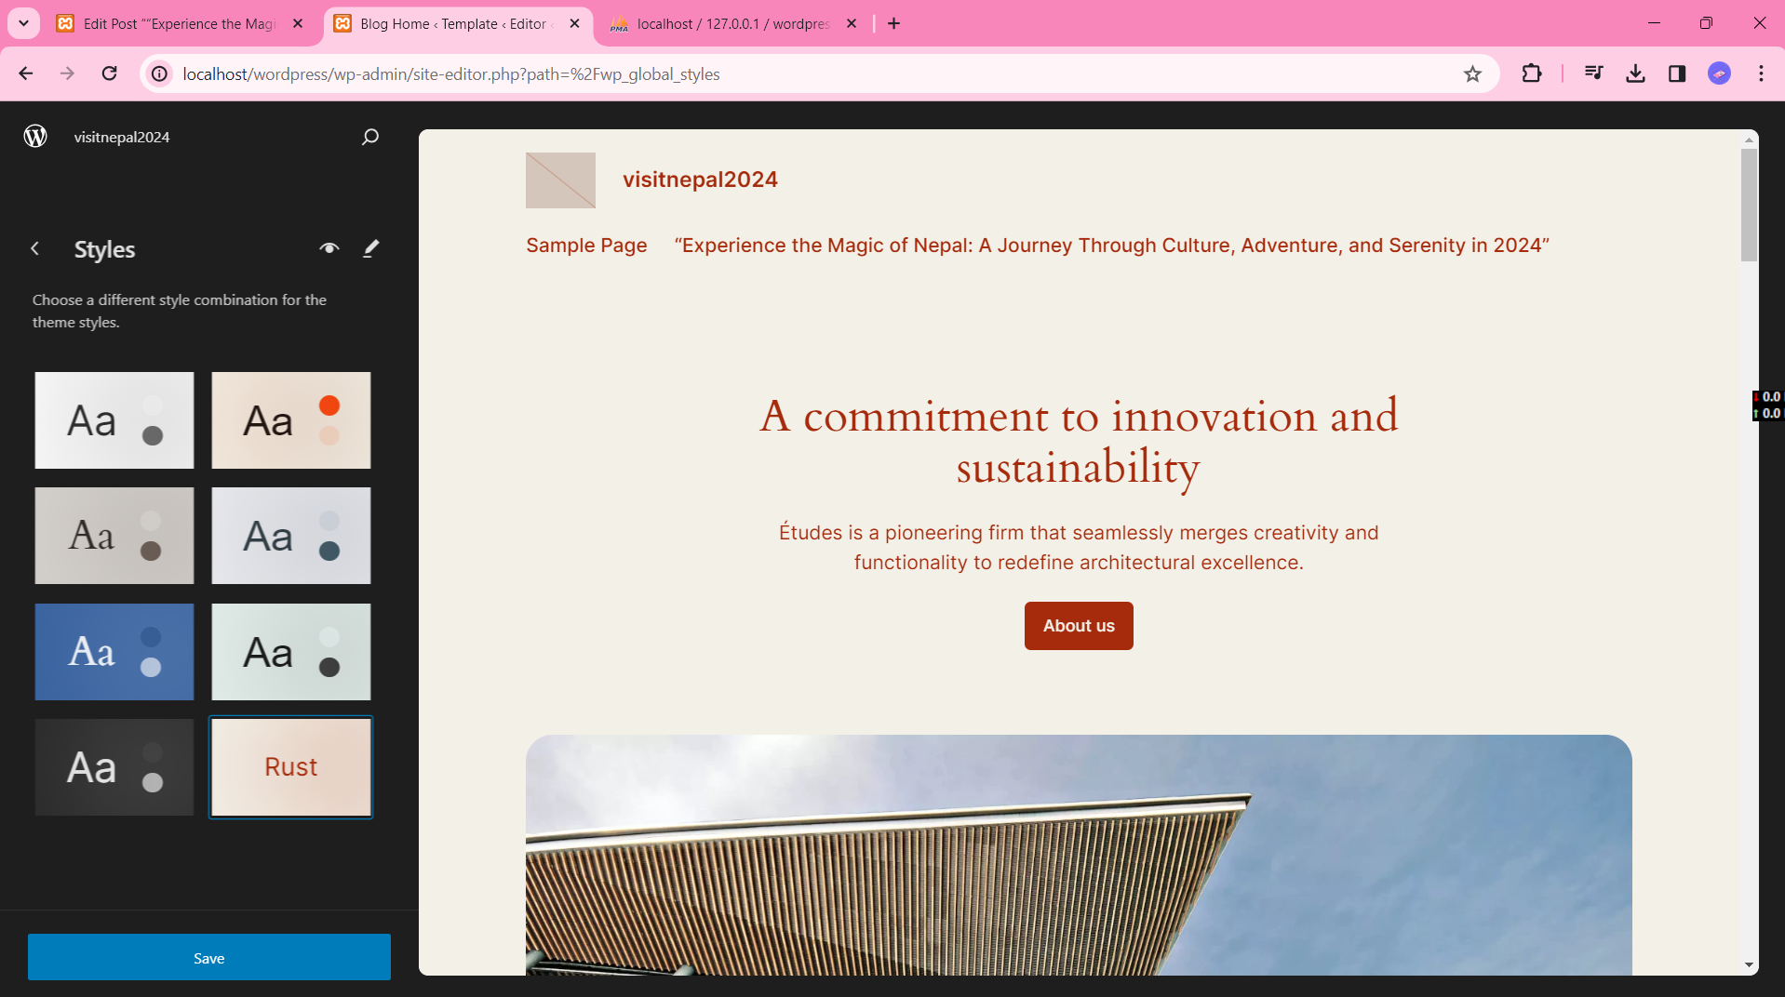

And the website theme color will be changed.